**Edmonds Community College Student Board of Trustees Application**

Thank you for your interest in applying for the student member position on the Edmonds Community College (EdCC) Board of Trustees. The Board of Trustees is the governing board of the college that makes policy and budget decisions including issues affecting students of EdCC. The Board of Trustees of EdCC unanimously approved a voting student member, as a sixth trustee on the board, to give students a greater voice in the governance of the college. The voting student member will participate in decision–making and provide insight into the impact of actions that trustees make which may not be measurable through reports or statistics. The student perspective can give the board a better understanding of the needs of a community college student.

**POSITION**: Student Member EdCC Board of Trustees

**OPENS**: February 9th, 2017  
**CLOSES**: March 17th, 2017

In this application package are all the necessary forms you will need to complete your application. Please read carefully and complete all the required information. **Application and all required documents MUST be submitted by Friday, March 17th, 2017.**

**PART ONE: STUDENT CONTACT INFORMATION**

Student Name (Print): ___________________________________________________

Student I.D. Number: __ __ __ - __ __ - __ __ __ __

Phone Number: (__ __ __) __ __ __ - __ __ __ __

Mailing Address: _______________________________________________________

City _________________ State _________________ Zip Code __________________

Email: ________________________________________________________________

**Student Member Position Requirements**

The Board of Trustees position requires the student representative to meet and maintain certain requirements including being able to attend Board of Trustee meetings.

Commitment to the position: **July 1st, 2017 to June 30th, 2018**

**MINIMUM REQUIREMENTS:**   
(Applicants must meet the minimum qualifications at the time of application)

1. Must be a full-time student (12 or more credits) at Edmonds Community College
2. Must have and maintain a minimum cumulative GPA of 2.70.
3. Must live within the **Edmonds Community College district.**
4. Must be planning to enroll at Edmonds Community College for the 2017-2018 academic years.
5. Must attend Board of Trustees meetings from July 2017 through June 2018.

**If the student member fails to be continuously enrolled at the college full-time or forfeits his or her academic standing, the student member is disqualified from serving.**

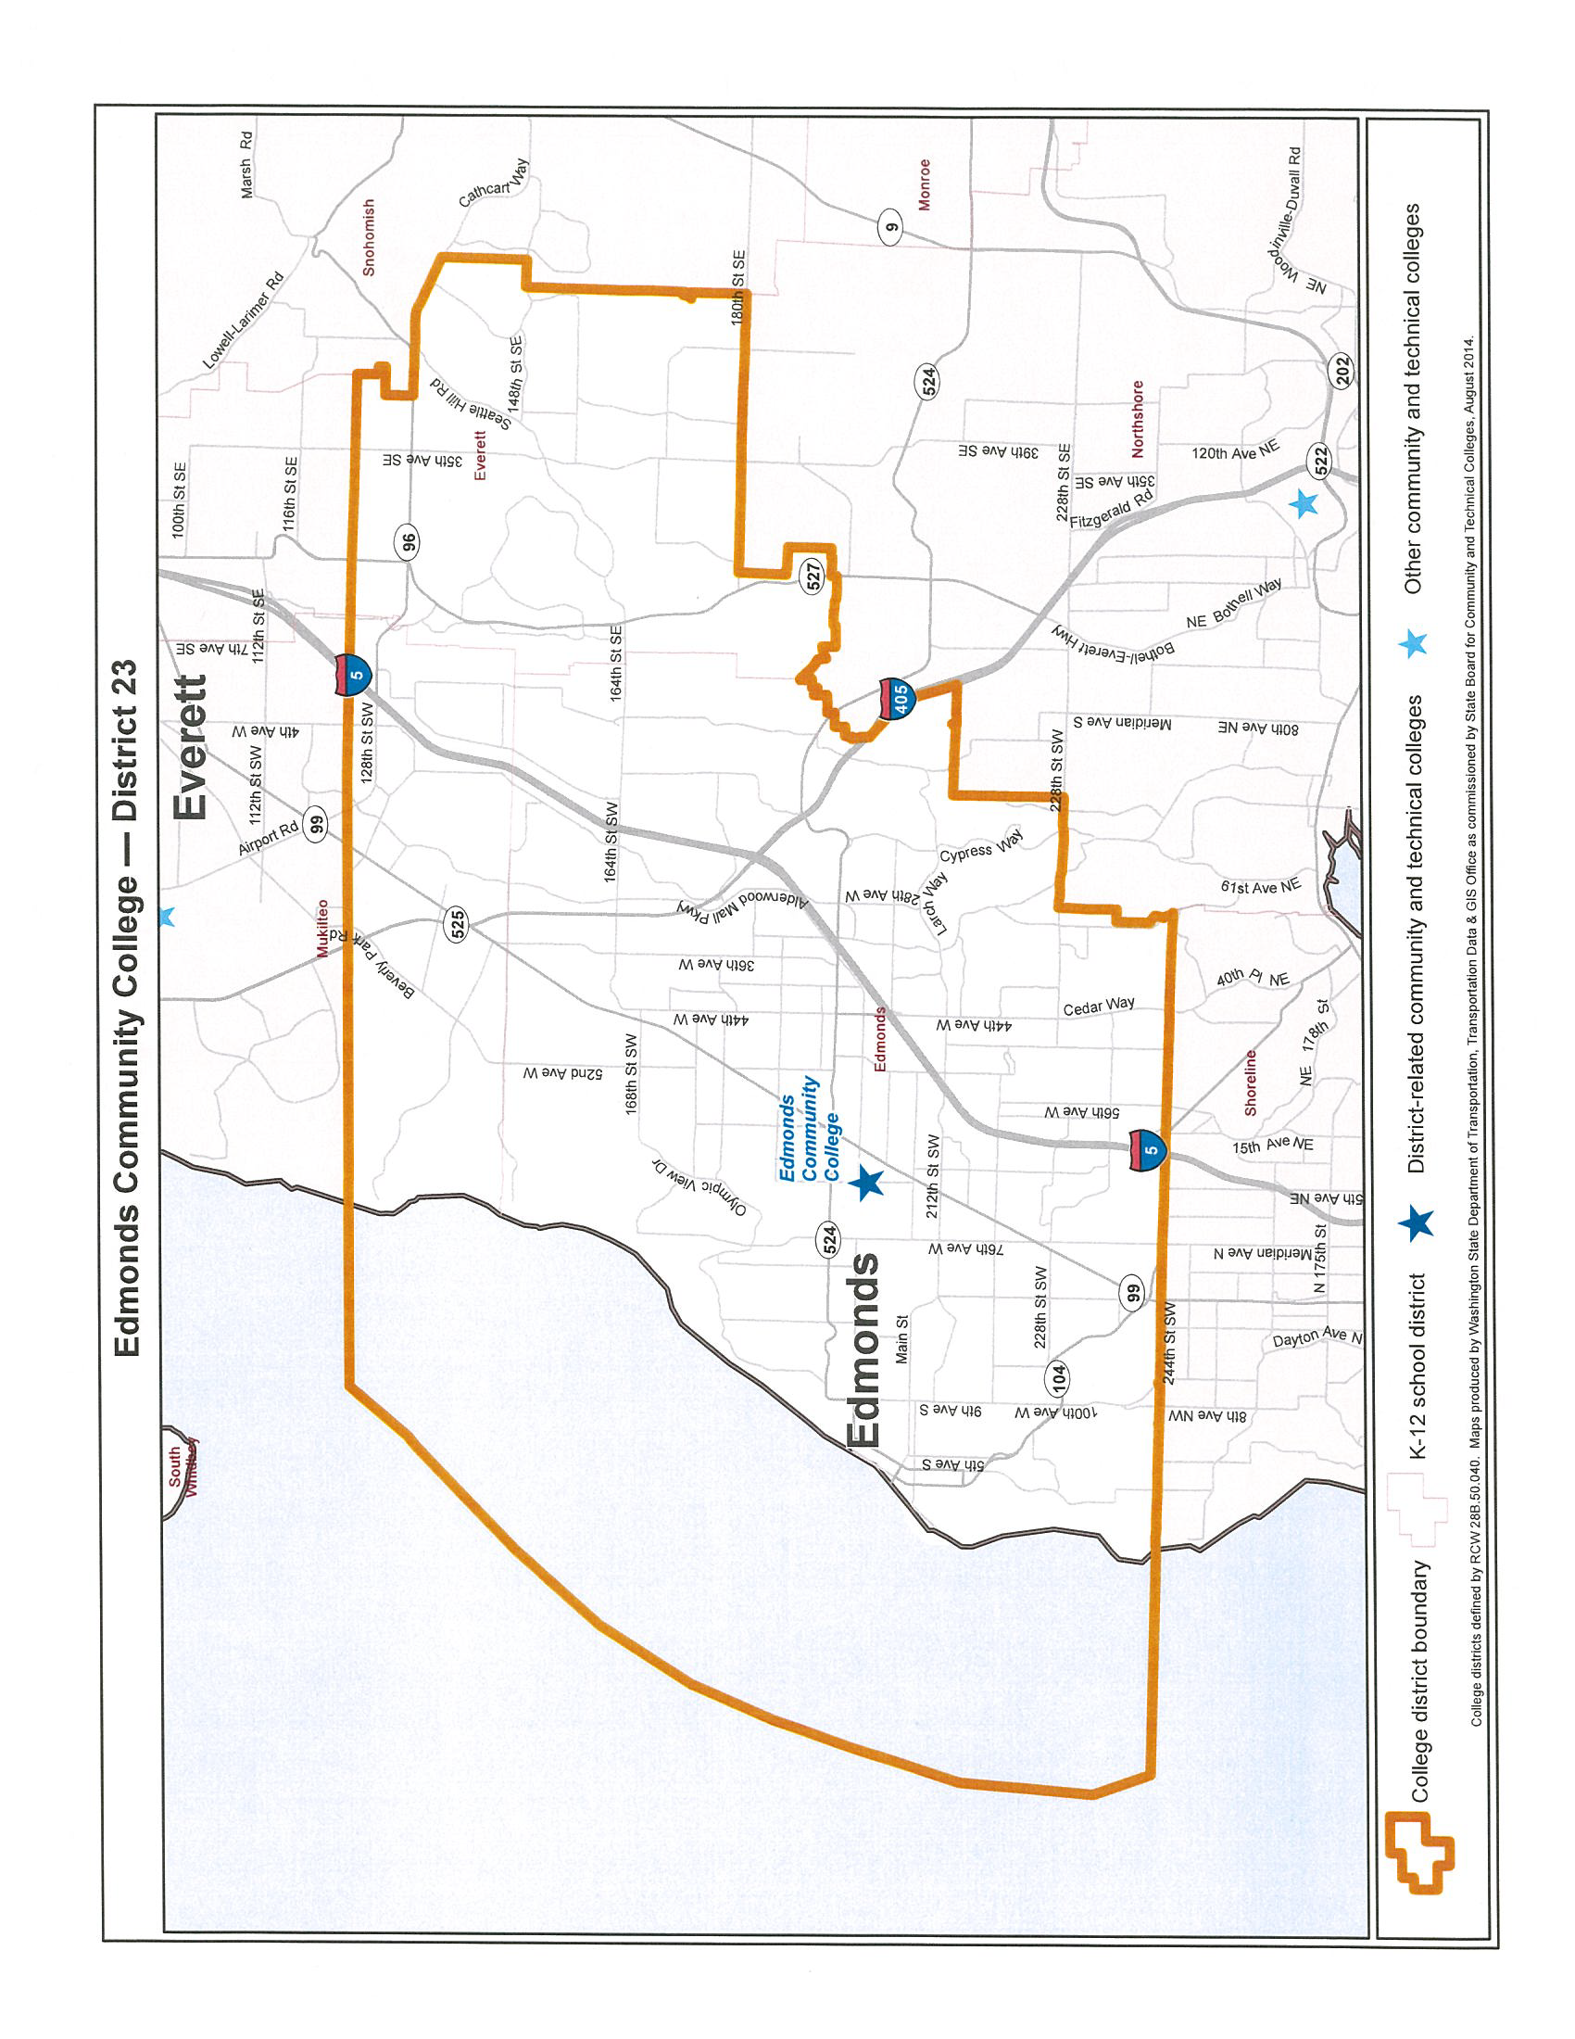

**PART TWO: HOW TO APPLY**

**REQUIRED DOCUMENTS TO SUBMIT WITH THE ASEdCC APPLICATION:***To be eligible for this position, applicants must meet the minimum qualifications and must submit a complete application packet which includes the following:*

1. A resume (no more than two pages in length) outlining your relevant experience and activities in:
2. Employment and Internships
3. Community Service/ Volunteering
4. Extra or Co-curricular Activities
5. Leadership Experience
6. Examples of Organizational Advocacy
7. A cover letter addressing the following points:
   1. Why you want this position.
   2. Academic and career goals at Edmonds (including approximate completion date) and beyond.
   3. Select one experience that can highlight the skills that are applicable to the position. Provide as much detail as possible.
   4. Any previous or current leadership experiences which you are or have been involved.
   5. Select two experiences (as listed in #1) to elaborate upon, one of which highlights your skills and experience. Provide as much detail as possible.
8. Two professional letters of recommendation. At least one must be from an Edmonds Community College faculty or staff member.
9. An unofficial transcript.
10. A current class schedule (You must be a full-time student with 12 or more credits).
11. Supplemental Questions:

*Please answer the following questions by providing specific examples and details. Limit your response to all questions, double-spaced, 300 maximum word limit per question.*

* If you were given a chance to talk to legislators about issues or concerns that students are facing, what you bring up to them?
* What strategies do you have to get the concerns from students, student leaders, staff, faculty, etc., and how do you envision the relationship between the student trustee and the various constituent groups as mentioned above?
* You are given a situation where there are different opinions within the student body about in increasing computer lab fees due to increased cost of purchasing and maintaining equipment. How would you respond to this situation where your opinion differs from the majority of students and you will be voting on the issue at an upcoming Board of Trustee meeting?
* What does diversity mean to you? Can you tell us why it is so important to be culturally

competent in the position of Student Trustee?

**PART THREE: SELECTION INFORMATION**

Interviews will be scheduled between April 10th - 12th. Selected candidates will be informed and advised on the next steps of the application process by April 12th.

Selection Screening Committee consists of the following:

* Three ASEdCC Executive Officers
* One Student at large
* One EdCC Board of Trustee Member
* One Administrator
* Advisor to ASEdCC Executive Board

Upon selection as a finalist, you will be asked to:

Submit an online application to the Governor of the State of Washington’s Office.

Application materials must be submitted to the **Center for Student Engagement and Leadership**, **Brier Triton Student Center 252**, by **April 17th, 2017**

For more information about the application process contact the Center for Student Engagement and Leadership at 425-640-1581 or email Maria French, ASEdCC Executive Officer for Diversity, at [asedcc_diversity@email.edcc.edu](mailto:asedcc_diversity@email.edcc.edu) or Wayne Anthony, Director, Center for Student Engagement and Leadership at [wanthony@email.edcc.edu](mailto:wanthony@email.edcc.edu).