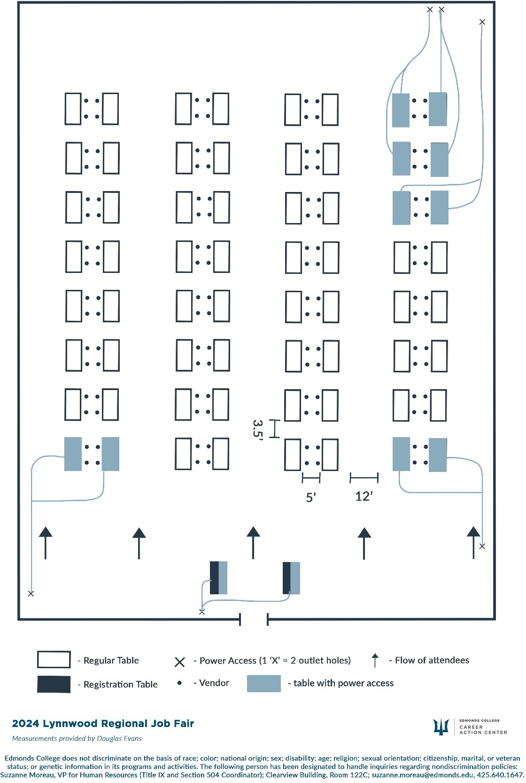Lynnwood Regional Job Floor Plan

|  |  |  |  |  |  |  |  |
| --- | --- | --- | --- | --- | --- | --- | --- |
| 1 | 9 | 17 | 25 | 33 | 41 | 49 | 57 |
| 2 | 10 | 18 | 26 | 34 | 42 | 50 | 58 |
| 3 | 11 | 19 | 27 | 35 | 43 | 51 | 59 |
| 4 | 12 | 20 | 28 | 36 | 44 | 52 | 60 |
| 5 | 13 | 21 | 29 | 37 | 45 | 53 | 61 |
| 6 | 14 | 22 | 30 | 38 | 46 | 54 | 62 |
| 7 | 15 | 23 | 31 | 39 | 47 | 55 | 63 |
| 8 | 16 | 24 | 32 | 40 | 48 56 64 | | |

Lynnwood set to launch its new brand and logo - Lynnwood Today